How to Confirm Your Attendance and Pay in Full

- Log-in to your myRedDragon account

- Select the Student tab (your home page may view slightly different)
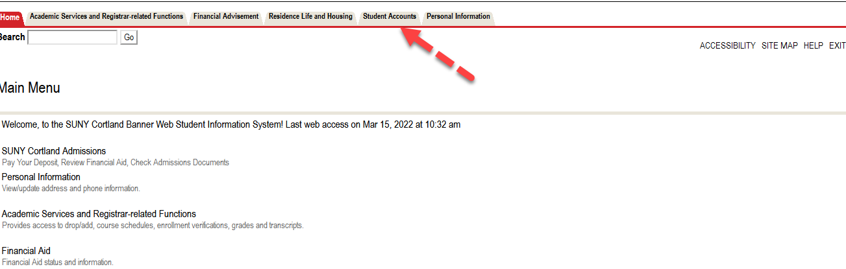

- Select Access Online Account
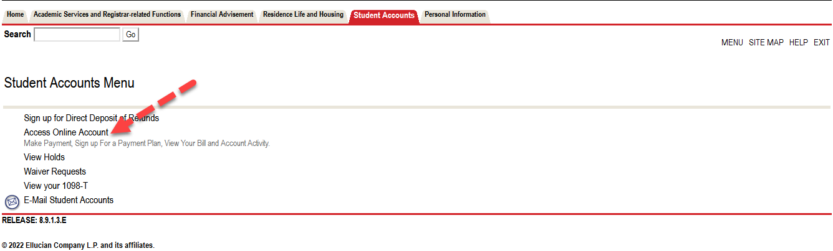

- Select term to confirm attendance
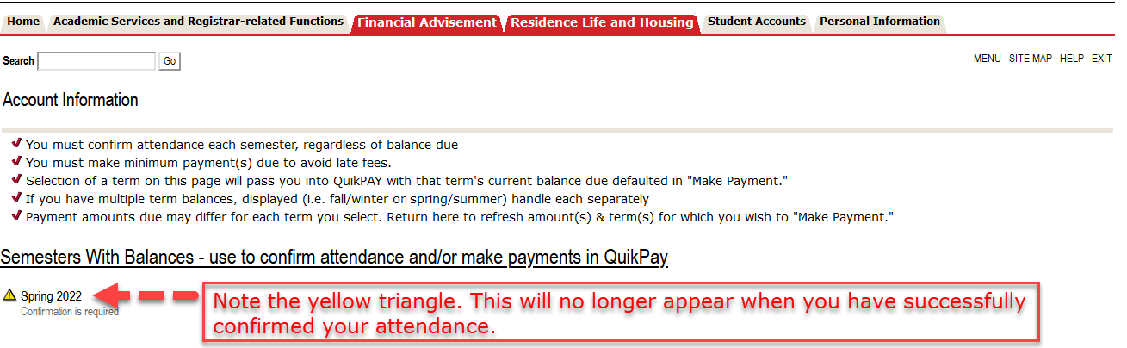

- Review your account summary and select “Accept/Pay or Decline.” All changes made to your student account will appear here in real time.
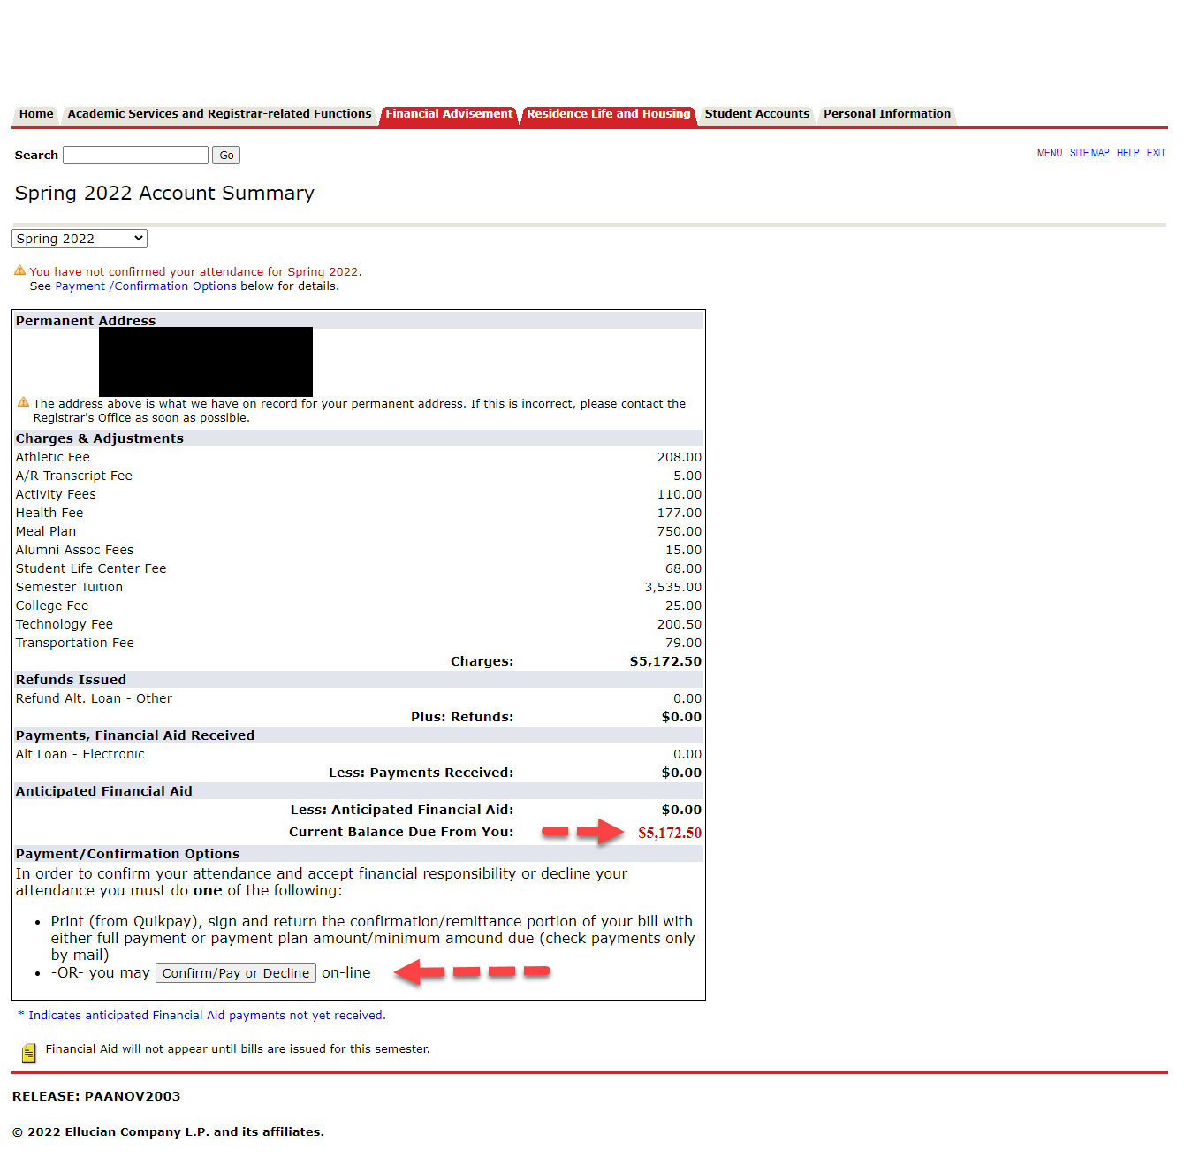

- Review verbiage, select “Accept” then “Continue” near the bottom of the page.
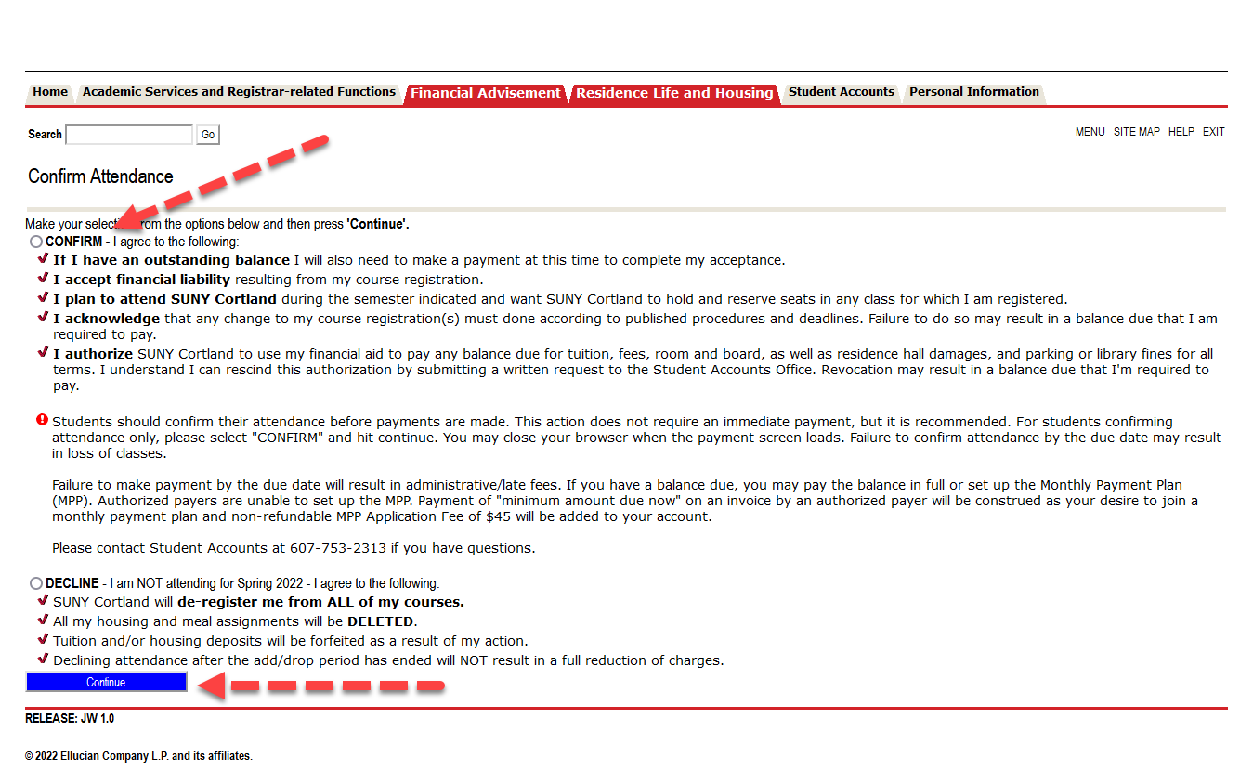
- Select “Pay Now in Full”
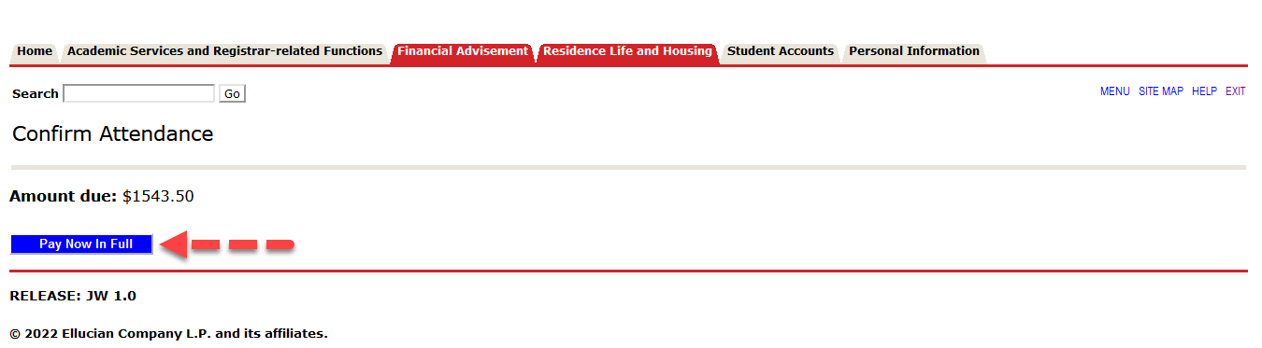

- You will now be placed in our 3rd party billing/payment vendor’s site (QuickPay) to complete your payment. From the menu on the left, select “View & Pay Accounts.”
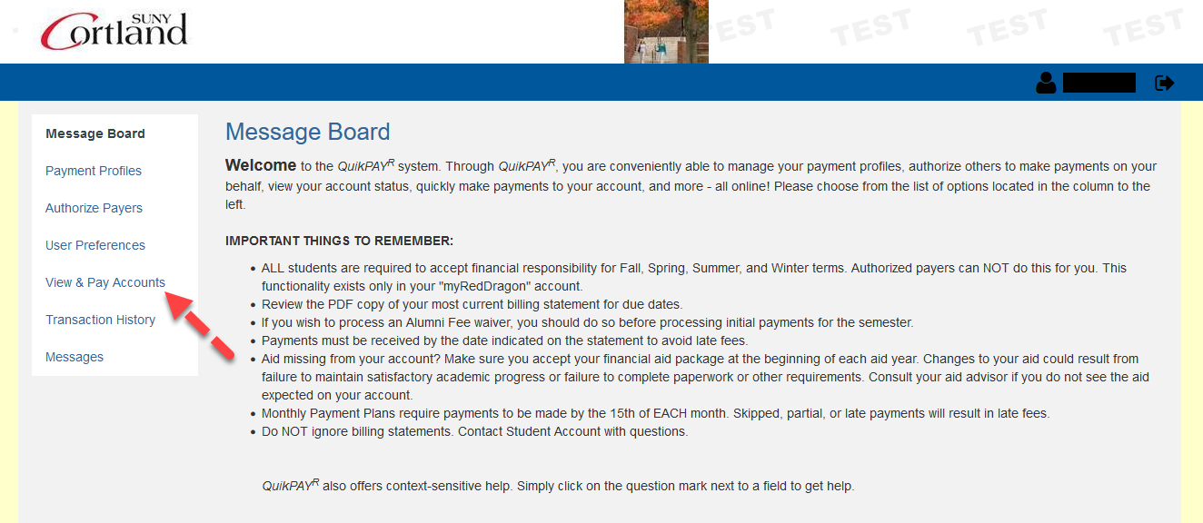
- Click “Make Payment”
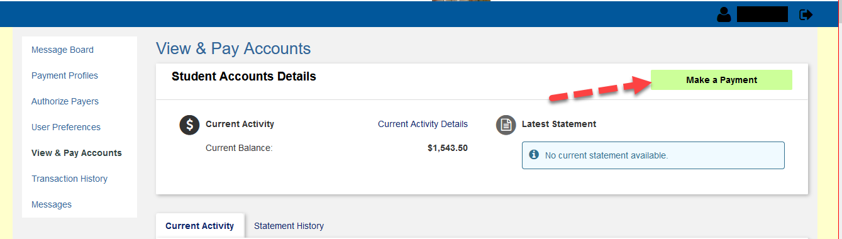
Once you click on make a payment, simply continue to complete your online payment by entering the amount and your credit card information.

